**AMERICAN INTERNATIONAL UNIVERSITY–BANGLADESH (AIUB)**

**DEPARTMENT OF ELECTRICAL AND ELECTRONIC ENGINEERING**

**DIGITAL LOGIC AND CIRCUITS LABORATORY**

**FALL 2023-2024**

**Section: Q, Group: 2, Exp No: 10**

**LAB REPORT ON**

Design of a Digital to Analog converter.

**Supervised By**

**DR. TANBIR IBNE ANOWAR**

**Submitted By:**

|  |  |
| --- | --- |
| Name | ID |
| NUSHRAT JAHAN | **22-46149-1** |
| MD. FAHIM MURSHED | **22-46695-1** |
| S.M. MUJAHID SOUROV | **22-49679-3** |
| MD. ATIK ISHRAK SUJON | **22-46684-1** |
| TRIDIB SARKAR | **22-46444-1** |

Date of Submission: **December 3th, 2023**

**Simulations:**

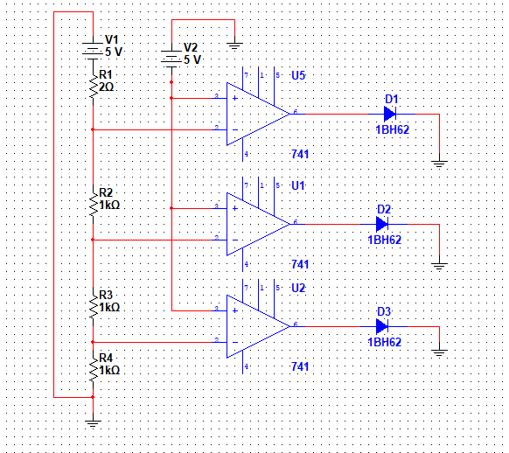

**Figure-1:** R/2R Ladder DAC

**Fig 2:** W2R Ladder DAC

**Fig 2**: W2R Ladder DAC